

**Group 2**

**Shaour Ahmad**

**Dil Jan Hameed Khan**

**Muhammad Shahzaib**

**Waqas Ahmad**

**1.DOMAIN MODEL**

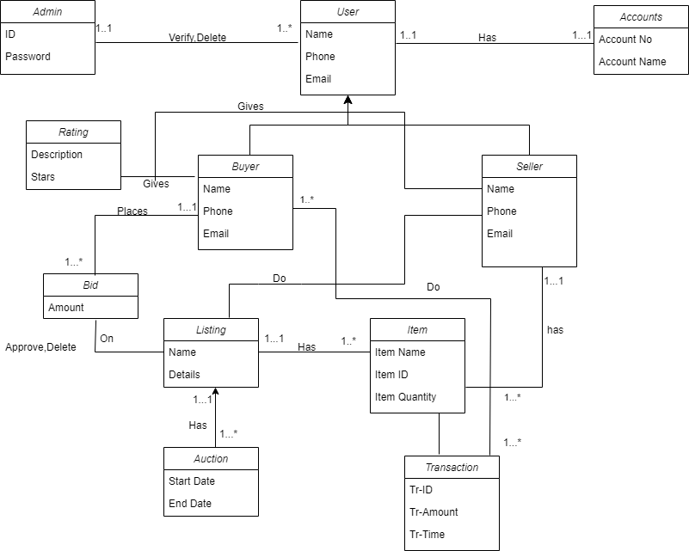

**2.System Sequence Diagram**

**Use Case : Payment**

**Shaour Ahmad(04072013035)**

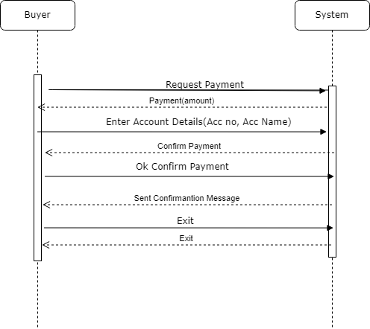

**Waqas Ahmed 006**System Sequence diagram **use-case: list item  
   
  
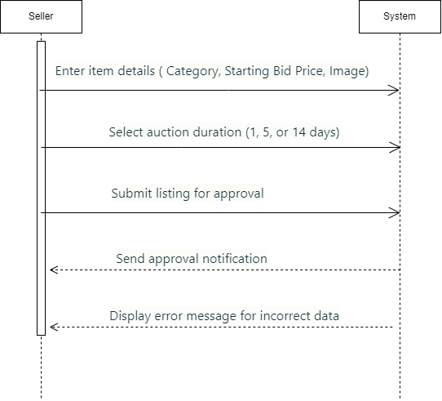**

**Name: Muhammad Shahzaib**

**Roll No: 04072113028**

**Group No: 02**

**System Sequence Diagram**

**UC: Remove Item from Listing**

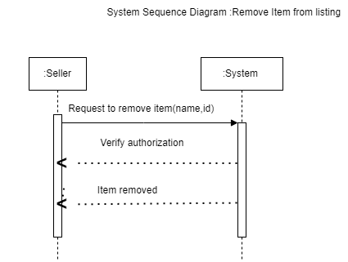

**Name: Diljan Hameed khan**

**Roll no: 04072113038**

**System Sequence Diagram**

**Use Case: Update Item**

